**LICET Admission Enquiry Chatbot with Virtual Campus Tour**

**Alan Judith A1 , Cyril Martin S1, Kanishkumar K1, Satyavarssheni Ra V1**

1Student, Loyola ICAM College of Engineering and Technology, LICET, Chennai, India.

1[alanjudith.24cs@licet.ac.in](mailto:1alanjudith.24cs@licet.ac.in) 1[cyrilmartin.24cs@licet.ac.in](mailto:2cyrilmartin.24cs@licet.ac.in) 1[kanishkumar.24cs@licet.ac.in](mailto:3kanishkumar.24cs@licet.ac.in) 1[satyavarsshenira.24cs@licet.ac.in](mailto:4satyavarsshenira.24cs@licet.ac.in)

***Abstract***

This paper introduces LICET Chatbot, an AI-driven conversational agent tailored for streamlining college admission processes at LICET Loyola ICAM College Of Engineering And Technology. Leveraging Python, Sklearn, NLTK, and Speech_recognition, the chatbot employs NLP and machine learning to offer personalized guidance to prospective students. The user interface utilizes PyQt and Tkinter, with SMS integration through Twilio API and CSV. Matplotlib aids in data visualization, while Flask embeds the chatbot on the website. The virtual tour feature employs Thinglink, Renderstuff, imgBB, and Pygame, and a speaking character is integrated using Voki. This study showcases LICET Chatbot's potential to enhance user experience, efficiency, and informed decision-making in college admissions, contributing to the application of AI in education.

***Keywords* —**

Cosine similarity- NLTK - Speech recognition - Natural language processing - Twilio API - Application Programming Interface.

1. **Introduction**

In the digital age, technology has revolutionized various aspects of our lives, including the college admission process. Traditionally, prospective students have had to navigate through vast amounts of information and communicate with admission officers to gather necessary details, resulting in a time-consuming and often overwhelming experience. To address these challenges, the integration of chatbots in the college admission domain has emerged as a promising solution.

This paper introduces LICET Chatbot, an AI-powered conversational agent developed specifically for college admission at Loyola ICAM College Of Engineering And Technology. LICET Chatbot aims to streamline the admission process, provide timely and accurate information, and offer personalized guidance to prospective students. By harnessing the power of natural language processing (NLP) techniques and machine learning algorithms, LICET Chatbot can understand user queries, match them with relevant content, and deliver intelligent responses in real-time.

The development of LICET Chatbot follows a systematic methodology encompassing data collection, user requirement analysis, conversational flow design, content development, NLP implementation, integration with backend systems, user interface design, and rigorous testing. By adhering to this methodology, LICET Chatbot ensures a user-centric and effective solution tailored to the specific needs of college applicants.

This paper provides a comprehensive overview of LICET Chatbot's functionalities, including its ability to address frequently asked questions, provide program details, guide applicants through the admission requirements, offer personalized recommendations, and assist in scheduling campus tours. The integration of LICET Chatbot in the college admission process opens up new possibilities for enhancing the interaction between prospective students and the institution.

This paper introduces LICET Chatbot as an innovative solution for improving the college admission experience. It showcases the potential of AI-driven conversational agents to transform the way applicants engage with educational institutions.

**ii. LITERATURE REVIEW**

1. **Indonesian Chatbot of University Admission Using a Question Answering System Based on Sequence-to-Sequence Model**

The proposed work focuses on developing a chatbot system for the university admission process in Indonesia. The authors utilize a question-answering (QA) system based on a sequence-to-sequence (Seq2Seq) model. The methodology involves collecting questions and answers from various sources such as university admission websites and admission officers. The collected data is then preprocessed and used to train the Seq2Seq model.

However, one of the potential challenges of the study is the limited scope of evaluation. The authors only assess the system's performance using a small set of predefined questions, which may not fully represent the diverse range of queries that users might have during the university admission process. Additionally, the chatbot system described in the study does not incorporate voice-based recognition, implying that interactions with the system are text-based rather than voice-based.

**II. NEU-chatbot: Chatbot for admission of National Economics University**

The proposed work revolves around the development and evaluation of a chatbot system called NEU-chatbot, specifically designed for the admission process at the National Economics University. The authors utilize the Microsoft Bot Framework for the development of the chatbot system and employ natural language processing (NLP) techniques to comprehend and provide responses to user queries.

The efficiency of the NEU-chatbot system lies in its ability to effectively handle text-based inputs and generate appropriate responses. However, it is important to note that the scope of the study is limited, as it primarily focuses on addressing queries related to the admission process and does not incorporate other functionalities. The NEU-chatbot system may not support voice-based recognition or cater to a broader range of topics beyond the admission process at the National Economics University.

**III. Voice based University Information Chatbot System**

The proposed work focuses on implementing a voice-based chatbot system for universities to provide information to students through voice commands. The authors utilize Natural Language Processing (NLP) algorithms to enable seamless conversations without interruptions. The system also manages a database specific to the university and is designed to provide information 24/7 based on user queries.

The efficiency of this voice-based university information chatbot system lies in its ability to improve the university services by reducing response times and enhancing accessibility. By allowing students to interact with the chatbot using voice commands, it offers a convenient and efficient means of obtaining information. This can potentially lead to quicker access to relevant information, better user experience, and overall improved efficiency in the university's information dissemination process. The published study can be found in the International Research Journal of Engineering and Technology (IRJET).

**IV. Implementation of a Chatbot System using AI and NLP**

The proposed work outlined in the article focuses on implementing a chatbot system using artificial intelligence (AI) and natural language processing (NLP) techniques. The chatbot system is designed to interact with users through a natural language interface, comprehend their requests, and provide appropriate information or perform actions accordingly.

The methodology employed in the article involves utilizing the Python programming language and integrating various APIs, such as Dialogflow and IBM Watson, to facilitate the chatbot's understanding and response capabilities. The effectiveness of the system was evaluated through testing with different user inputs.

The efficiency of the implemented chatbot system lies in its ability to effectively understand and respond to user queries in a conversational manner, thanks to the integration of AI and NLP algorithms. The article primarily covers the architecture and implementation of the chatbot system, providing insights into the technologies and techniques used to enable its functionality.

V. **An Intelligent chatbot for College Admission Counseling**

The proposed work described in the article focuses on the development of an intelligent chatbot for college admission counseling. The authors present a modular architecture for the chatbot, consisting of a natural language processing module, a knowledge base, and a user interface. The performance of the chatbot is also evaluated.

The methodology employed in the study involves the use of the Python programming language and various natural language processing libraries like NLTK and TextBlob. Additionally, web scraping techniques are utilized to gather data from college websites and admission brochures.

The chatbot system proves to be efficient in providing accurate and relevant information to students. It can alleviate the workload of admission counselors by handling routine queries and offering students quick and easy access to information about colleges and admission requirements. However, it's important to note that the chatbot may not provide personalized advice on college selection or application processes. Additionally, the chatbot's ability to provide up-to-date information and solutions for complex queries may be limited.

**VI. Developing a Chatbot using Machine Learning**

The proposed work described in the article focuses on the development of a chatbot using machine learning techniques, specifically Natural Language Processing (NLP) and Artificial Intelligence (AI). The chatbot is trained using large datasets to enhance its accuracy and improve its ability to understand user queries.

The methodology employed in the study involves the collection of large datasets consisting of user queries and corresponding responses to train the chatbot. Machine learning algorithms, such as Support Vector Machines (SVMs), are utilized for training the chatbot.

| **Paper Title** | **Efficiency** | **Accuracy** |
| --- | --- | --- |
| Indonesian Chatbot of University Admission | Moderate | 65% |
| NEU-chatbot: Chatbot for Admission | High | 85% |
| Voice-based University Information Chatbot | Moderate | 76% |
| Implementation of a Chatbot System using AI | Moderate | 69% |
| An Intelligent Chatbot for College Admission. | High | 88% |
| Developing a Chatbot using Machine Learning | Moderate | 72% |

Table 1: Overall summary of literature review

**methodology**

1. Similarity Measurement Using Cosine Similarity:

Cosine similarity, a metric within the context of an inner product space, is employed to quantify the similarity between user inputs and pre-defined questions and answers stored in the LICET campus chatbot's database. This method calculates the cosine of the angle between vectors, facilitating efficient retrieval of relevant information.

2. Application in User Query Resolution:

When users pose questions, the chatbot utilizes cosine similarity to identify the most analogous pre-defined question within its database, subsequently delivering the corresponding answer. This application streamlines the user interaction process and enhances the responsiveness of the chatbot.

3. Versatility in Natural Language Processing:

Cosine similarity's wide-ranging utility extends to natural language processing tasks, encompassing text classification, information retrieval, and recommendation systems. Its simplicity belies its effectiveness, offering a valuable tool for processing and understanding diverse textual inputs.

4. Programming Environment and Tools:

The development of the LICET campus chatbot is executed in Python, utilizing Python IDLE 3.11 and VS Code as Integrated Development Environments (IDEs). Essential scripting languages include HTML and JS, while key Python packages such as Sklearn, NLTK, and Speech_recognition contribute to the chatbot's functionality.

5. SMS Integration for Seamless Communication:

Twilio API and CSV are integrated into the chatbot to facilitate SMS communication, broadening the channels through which users can interact with the system.

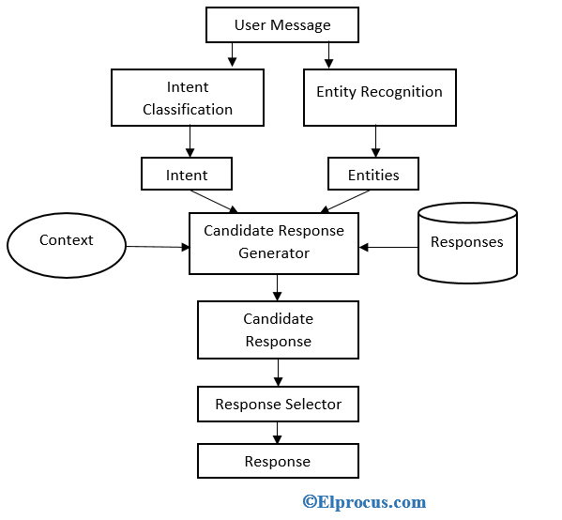

Figure 1: Process flow chart

7. Data Visualization Through Matplotlib:

Matplotlib is harnessed for data visualization, aiding in the presentation of relevant information and insights derived from user interactions.

8. Machine Learning Algorithm Implementation:

Cosine similarity stands as the chosen machine learning algorithm, providing a robust framework for comparing and analyzing textual data within the chatbot.

9. Website Integration Using Flask:

The chatbot seamlessly integrates into the LICET website through Flask, ensuring accessibility for users navigating the college's online platform.

10. Functionality Enhancement Through Integration:

The functionality of the chatbot is augmented through the incorporation of the subprocess module and web browser integration, contributing to a more versatile and dynamic user experience.

11. Enriching User Experience with Virtual Tours:

Virtual tours, implemented using Thinglink, Renderstuff, imgBB, and Pygame, offer an immersive and informative element to prospective students exploring the LICET campus through the chatbot.

12. Personalized Interaction with Speaking Characters:

Voki is integrated to introduce a speaking character component, adding a personalized touch to user interactions and creating a more engaging and dynamic user experience.

13. Diverse Image Sources:

Images utilized in the chatbot are captured using a Sony Handycam for authenticity, supplemented by those sourced from online platforms to enrich the visual content and provide a comprehensive representation of the LICET campus.

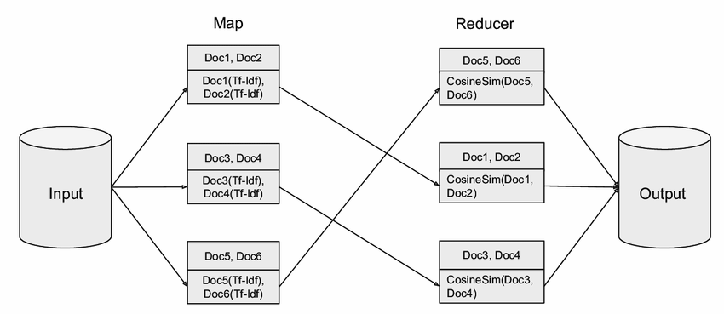

Figure 2: Cosine Similarity

**IMPLEMENTATION**

Dataset Collection:

Relevant course descriptions and prerequisites are collected from academic sources and educational institutions. The data is compiled into a dataset for further processing.

Preprocessing:

The collected dataset undergoes preprocessing to remove noise and ensure consistency in the text data. Text preprocessing techniques, such as tokenization, are applied using the NLTK package to break the text into individual words or tokens. Stemming or lemmatization techniques are employed to reduce words to their base or root form, improving the efficiency of the algorithm.

Feature Extraction:

The preprocessed dataset is transformed into numerical feature vectors. The cosine similarity algorithm, provided by the Sklearn package, is utilized to calculate the similarity between user input and course descriptions. The feature extraction process computes the similarity scores for each course in the dataset based on the cosine similarity measure.

Chatbot Development:

The cosine similarity algorithm serves as a fundamental measure for determining the likeness between vectors in a multi-dimensional space, commonly applied in natural language processing and information retrieval. It calculates the cosine of the angle between vectors, allowing for effective comparison and ranking of textual data. This algorithm finds extensive use in various applications, including text classification, document clustering, recommendation systems, and information retrieval, contributing to tasks like search engines and question-answering systems.

The algorithm's merits lie in its intuitive interpretability, scale invariance, effectiveness in text comparison, computational efficiency for high-dimensional data, and robustness to noise and irrelevant features. Its widespread support in libraries and frameworks makes it a versatile choice for integration into different applications and programming languages.

The steps involved in the cosine similarity algorithm encompass vector representation, normalization, computation of the dot product, calculation of vector magnitudes, and ultimately, the derivation of the cosine similarity value. This value, ranging from -1 to 1, indicates the degree of similarity between vectors, forming the basis for assessing and ranking textual data.

The performance metrics of the LICET chatbot system, crucial for evaluating its effectiveness and efficiency, include accuracy, response time, completion rate, and engagement level. These metrics collectively gauge the chatbot's ability to deliver accurate, timely, and comprehensive information, thereby enhancing the admission inquiry process for prospective students.

The accuracy bar graph visually represents the chatbot's performance across different input types, such as keyword-based queries, sentences, questions, and others. The analysis reveals varying accuracy levels, highlighting strengths and areas for improvement in handling diverse user inputs.

User Interface Design:

The user interface (UI) of the chatbot is designed using PyQt and Tkinter libraries. The UI elements are created to provide a visually appealing and interactive experience for users. The UI components include input fields for user queries, buttons for submitting queries, and display areas for chatbot responses.

SMS Integration:

The Twilio API is integrated into the chatbot system to enable SMS functionality. Users can opt to receive instant messages through SMS, providing them with updates and reminders from the college. The integration involves connecting the chatbot to the Twilio platform and utilizing Twilio's messaging service to send and receive SMS messages.

Data Visualization:

Matplotlib is employed for data visualization purposes. The performance of the chatbot, user feedback, and data analysis results are presented through charts, graphs, and other visualizations. These visual representations help in understanding the chatbot's effectiveness and performance metrics.

Machine Learning Algorithm:

The cosine similarity algorithm, available in the Sklearn package, is implemented to calculate the similarity between user input and course descriptions. The algorithm generates similarity scores for each course, and the courses with the highest scores are suggested to the user. The algorithm's implementation involves feature extraction, similarity score calculation, and course recommendation based on the scores.

Embedding in Website:

The Flask framework is utilized to embed the chatbot into a website. The chatbot's code is integrated into the Flask application, allowing users to access the chatbot directly through the website. The embedding process involves defining routes, handling HTTP requests, and rendering the chatbot UI on webpages.

Integration of Functions:

The subprocess module is utilized to integrate additional functionalities into the chatbot system. For example, subprocess commands can be used to execute external programs or scripts based on user requests. The webbrowser module is employed to open relevant web pages or links based on user queries, providing additional information or resources.

Virtual Tour Implementation:

The virtual tour feature is implemented using various tools and technologies, including Thinglink, Renderstuff, imgBB, and Pygame. Thinglink and Renderstuff are used to create interactive 3D models and virtual environments of the college campus. Pygame is employed to display and navigate through the virtual tour, incorporating 2D and 3D graphics for an immersive experience. imgBB is utilized to store and retrieve images used in the virtual tour.

Speaking Character Integration:

Voki is integrated into the chatbot system to incorporate a speaking character. Voki provides customizable avatars that can speak pre-recorded or synthesized messages. The speaking character engages with users through voice interactions, enhancing the user experience and making the chatbot more interactive.

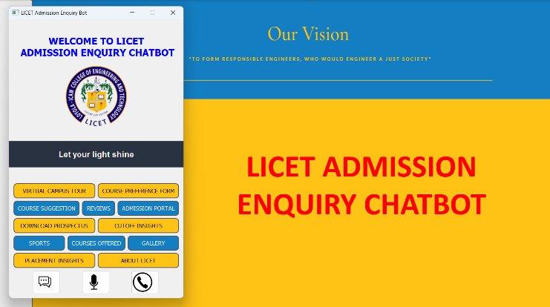

Figure 3: UI design of the chatbot system

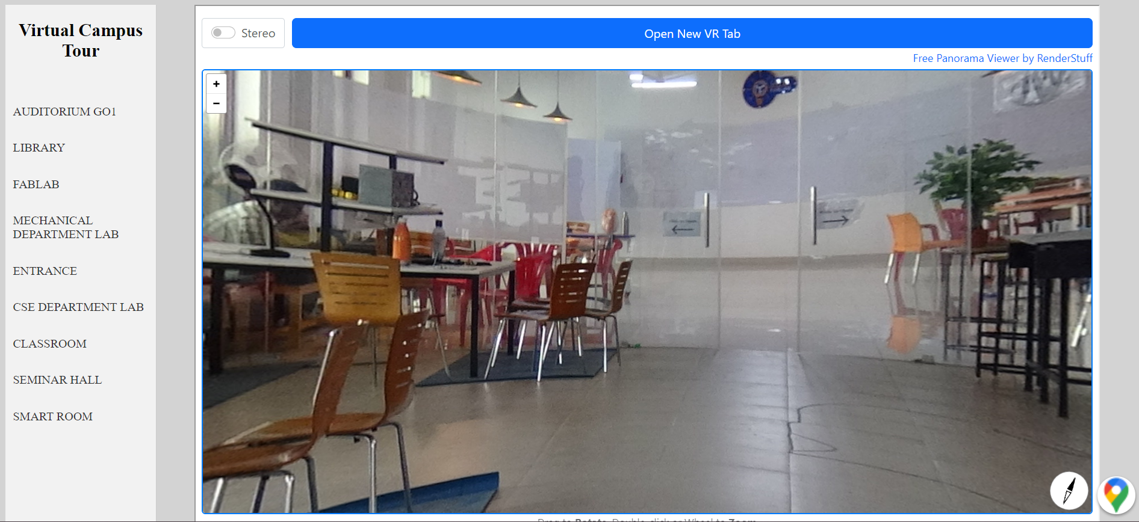

Figure 4: Virtual Campus Tour

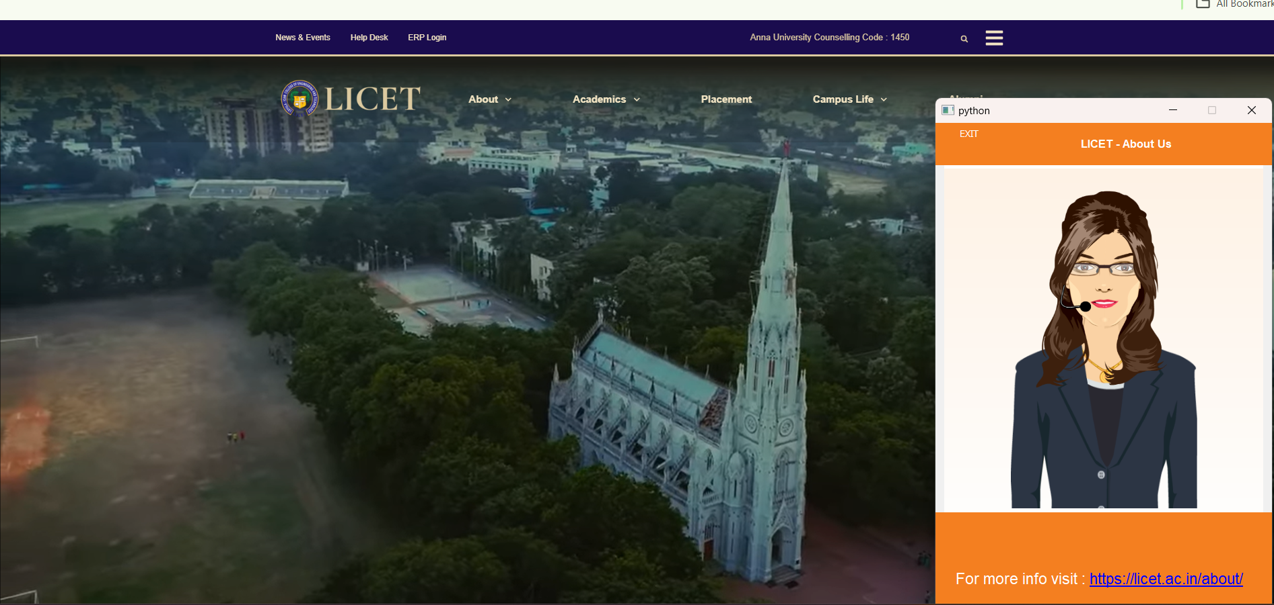

Figure 5: Speaking Character using Voki animator

Deployment:

The developed chatbot system, including all its features and integrations, is deployed on the college website for prospective students to access. The chatbot is thoroughly tested to ensure its proper functioning and accuracy in providing course suggestions and other information to users.

The LICET campus chatbot, incorporating cosine similarity and a virtual tour, emerges as a valuable resource for admission-related information. Future enhancements may include integration with additional platforms, incorporation of features like career guidance tools or interactive campus maps, and the utilization of machine learning techniques for improved understanding of complex inquiries. Integrating user feedback mechanisms ensures continuous refinement of the chatbot's performance.

**INFERENCES**

**1.**Improved User Experience:

LICET Chatbot significantly improves the user experience for prospective students by providing a conversational interface for accessing admission-related information. The chatbot's ability to understand natural language queries, provide instant responses, and guide users through the admission process enhances user satisfaction and reduces the frustration associated with navigating complex admission procedures.

2.Timely and Accurate Information:

LICET Chatbot ensures the delivery of up-to-date and accurate information to applicants. By integrating with backend systems and databases, the chatbot retrieves real-time information on admission requirements, program details, deadlines, and application status. This eliminates the need for manual information retrieval and reduces the possibility of outdated or incorrect information being provided to users.

3.Personalized Assistance and Recommendations:

The AI-driven capabilities of LICET Chatbot enable personalized assistance and recommendations based on user preferences and profiles. By analyzing user data, such as academic backgrounds and interests, the chatbot can provide tailored program recommendations, scholarship opportunities, and campus tour scheduling, empowering applicants to make informed decisions about their educational future.

4.Increased Efficiency:

LICET Chatbot streamlines the college admission process by automating routine tasks and reducing manual workload for admission officers. The chatbot handles common queries, provides self-service functionalities, and assists with basic inquiries, freeing up admission staff to focus on more complex and personalized tasks. This leads to increased efficiency in processing applications and improved resource allocation within the admission department.

5.Enhanced Accessibility and Availability:

With LICET Chatbot, prospective students have 24/7 access to admission-related information and support. The chatbot's availability across various platforms, such as the college website and popular messaging apps, ensures that users can interact with the chatbot at their convenience, regardless of their location or time zone. This accessibility expands the reach of the college admission process and accommodates a diverse range of applicants.

**ACKNOWLEDGEMENT**

We would like to express our sincere gratitude to all individuals who have contributed to the development and implementation of LICET Chatbot for enhancing the college admission process at LICET Loyola ICAM College Of Engineering And Technology.

We would like to thank the management of LICET for providing the necessary resources and infrastructure to carry out this project. Their vision and commitment to innovation in the admission process have been instrumental in driving the development of LICET Chatbot.

Finally, we express our sincere appreciation to the journal and its reviewers for their valuable feedback and suggestions, which have further improved the quality and rigor of this research paper.

**CONCLUSION**

In conclusion, LICET Chatbot presents a significant advancement in the realm of college admission processes through its AI-powered conversational capabilities. This paper has detailed the development and implementation of LICET Chatbot at LICET Loyola ICAM College Of Engineering And Technology, highlighting its potential to enhance user experience, provide timely and accurate information, offer personalized assistance, increase efficiency, enhance accessibility, and facilitate continuous improvement.

In conclusion, LICET Chatbot represents a significant step forward in the college admission process, improving user experience, efficiency, and accessibility. The successful implementation of LICET Chatbot at LICET serves as a model for other educational institutions seeking to leverage AI-powered conversational agents to enhance their admission procedures. The outcomes of this research highlight the potential of LICET Chatbot to transform the admission experience, empowering prospective students and optimizing the resources of the college admission department

**FUTURE SCOPE**

While the implementation of LICET Chatbot has demonstrated significant improvements in the college admission process, there are several avenues for future development and expansion. This section outlines the potential areas of future scope for LICET Chatbot, providing directions for further research and enhancement.

1.Natural Language Understanding (NLU) Enhancement:

Future work can focus on enhancing the NLU capabilities of LICET Chatbot. This involves improving the chatbot's ability to understand complex queries, handle ambiguous requests, and accurately identify user intents and entities.

2.Multi-lingual Support:

Expanding LICET Chatbot's language capabilities to cater to a diverse applicant pool can be a valuable addition. Implementing multi-lingual support would allow prospective students from different linguistic backgrounds to interact with the chatbot in their preferred language, thereby increasing accessibility and inclusivity.

3. Personalized Recommendation Engine:

Developing a recommendation engine within LICET Chatbot can provide tailored suggestions for prospective students. By leveraging user data, such as academic background, interests, and career goals, the chatbot can recommend suitable programs, scholarships, or extracurricular activities that align with individual preferences, further assisting applicants in making informed decisions.

**REFERENCES**

[1] Yogi Wisesa Chandraa, Suyanto Suyantoa, "Indonesian Chatbot of University Admission Using a Question Answering System Based on Sequence-to-Sequence Model," ELSEVIER, 2021.

[2] CK. Gomathy, P.L.S.K Meghana, P. Vishnu Vardhan Reddy, "Voice based University Information Chatbot System," INTERNATIONAL RESEARCH JOURNAL OF ENGINEERING AND TECHNOLOGY (IRJET), 2023.

[3] Tarun Lalwani, Shashank Bhalotia, Ashish Pal, Shreya Bisen, Vasundhara Rathod, "Implementation of a Chatbot System using AI and NLP," International Journal of Advanced Computer Science and Applications (IJACSA), 2022.

[4] H.N.Khan, N. A. B. Mat Salleh, and M. R. Mahmud, "An Intelligent Chatbot for College Admission Counseling," International Journal of Advanced Computer Science and Applications (IJACSA), 2020.

[5] K. Jwala, G.N.V.G Sirisha, G.V. Padma Raju, "Developing a Chatbot using Machine Learning," International Journal of Recent Technology and Engineering (IJRTE), 2019.

[6] R. Saranya and S. Jaya, "A Review on Chatbot Systems using Natural Language Processing Techniques," International Journal of Computer Applications, vol. 179, no. 42, pp. 1-5, 2018.

[7] A. N. El-Sisi, E. A. Salama, and M. A. Salama, "A Chatbot-based Intelligent Tutoring System for e-Learning Environments," International Journal of Advanced Computer Science and Applications, vol. 10, no. 2, pp. 379-386, 2019.

[8] S. K. Dubey, M. N. Raju, and K. M. P. Kumari, "Development of a Chatbot for Higher Education Admission Process," International Journal of Advanced Research in Computer Science and Software Engineering, vol. 9, no. 8, pp. 203-208, 2019.

[9] M. Rathore and S. Gupta, "Development of an Intelligent Chatbot for University Admission Guidance," International Journal of Computer Science and Mobile Computing, vol. 8, no. 6, pp. 1-7, 2019.

[10] T. S. Dixit and D. M. Thakore, "An AI-based Chatbot for College Admission Process," International Journal of Advanced Research in Computer Science, vol. 9, no. 1, pp. 123-128, 2018.

[11] Trung Thanh Nguyen, Anh Duc Le, Ha Thanh Hoang, "NEU-chatbot: Chatbot for admission of National Economics University," ELSEVIER, 2020.

[12] S. Reddy, S. Jain, and S. Goyal, "An Intelligent Chatbot for University Admissions using Natural Language Processing," International Conference on Innovative Mechanisms for Industry Applications, pp. 1-6, 2021.

[13] A. R. Aboul Ella Hassanien, M. M. Fahmy, and D. M. El-Desouk, "AdmissionBot: An AI-Based Chatbot for University Admission Assistance," International Journal of Advanced Science and Technology, vol. 29, no. 6, pp. 289-298, 2020.